# BLOCKCHAIN

**LINKEDIN POST: ( 1167 characters ) MAX = 1300**

* Unlike traditional methods, blockchain enables peer-to-peer transfer of digital assets without any intermediaries. It was a technology originally created to support the famous cryptocurrency, BitCoin.
* A blockchain is, in the simplest of terms, a time-stamped series of immutable records of data that is managed by a cluster of computers not owned by any single entity. Each of these blocks of data (i.e. block) is secured and bound to each other using cryptographic principles (i.e. chain).
* It is not owned by a single entity, hence it is decentralized.

The three main properties of Blockchain Technology are:

1. **Decentralization**

In a decentralized system, the information is not stored by one single entity. In fact, everyone in the network owns the information.

1. **Immutability**

It means once data has been written to a blockchain no one, not even a system administrator, can change it.

1. **Transparency**

Because of the decentralized nature of Bitcoin’s blockchain, all transactions can be transparently viewed by either having a personal node or by using blockchain explorers that allow anyone to see transactions occurring live.

#blockchain #cryptocurrency #bitcoin #indiawantscrypto

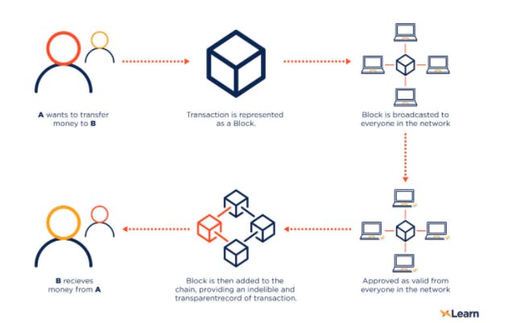

**FACEBOOK POST:**

Blockchain is a system of recording information in a way that makes it difficult or impossible to change, hack, or cheat the system.

The first cryptocurrency was Bitcoin launched in 2009 by **Satoshi Nakamoto** who is still unknown as of today. **Bitcoin** was a huge success and there are also a number of competing cryptocurrencies known as altcoins.

As of today, there are literally thousands of cryptocurrencies in existence with an aggregate market value of over $2.43 trillion.

**Why Blockchain has gained so much admiration?**

* It is not owned by a single entity, hence it is decentralized.
* The data is cryptographically stored inside.
* Blockchain transactions are near-instant, irreversible, and, in public blockchains, anonymous by design.

The three main properties of Blockchain Technology are:

1. Decentralization
2. Transparency
3. Immutable

